### Module : 9 – Reactjs,Components , states ,props

1] Create Hello World React program show below.

Index.js

Import React from 'react';

import ReactDOM from 'react-dom';

import'./App.css';

functionApp() {

  return (

    <div className ="App">

      <h1>react app</h1>

      <imgsrc="https://upload.wikimedia.org/wikipedia/commons/a/a7/React-icon.svg"alt="React Logo" className="logo"/>

      <h1>Hello World</h1>

    </div>

  );

}

ReactDOM.render(<App/>, document.getElementById('root'));

root.render(

  <React.StrictMode>

    <App/>

  </React.StrictMode>

);

**css**

body {

  margin: 0;

  padding: 0;

  display: flex;

  justify-content: center;

  align-items: center;

  height: 100vh;

  background-color: black;

}

.App {

  text-align: center;

  color: cyan;

}

.logo {

  width: 100px;

  margin-bottom: 20px;

}

Output:

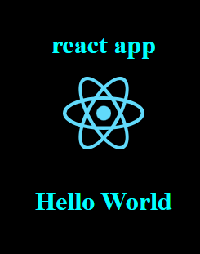

2]Create counter app program shown below.

**Step 1: Set Up Your ReacStep 1: Set Up Your React App**

npx create-react-app counter-app

cd counter-app

npm start

### Step 2: Create the Counter Component

importReact, { useState } from'react';

constCounter= () => {

  const [count, setCount] =useState(0);

  return (

    <divstyle={{ textAlign:'center', marginTop:'50px' }}>

      <h1>Counter App</h1>

      <h2>{count}</h2>

      <buttononClick={() =>setCount(count + 1)}style={{ marginRight:'10px', padding:'10px', backgroundColor:'green', color:'white' }}>Increment</button>

      <buttononClick={() =>setCount(count - 1)}style={{ padding:'10px', backgroundColor:'red', color:'white' }}>Decrement</button>

    </div>

  );

};

exportdefaultCounter;

### Step 3: Use the Counter Component

importCounterfrom"./Counter";

functionApp() {

  return (

    <div>

      <Counter/>

    </div>

  );

}

exportdefaultApp;

### Step 4: Run Your App

npm start

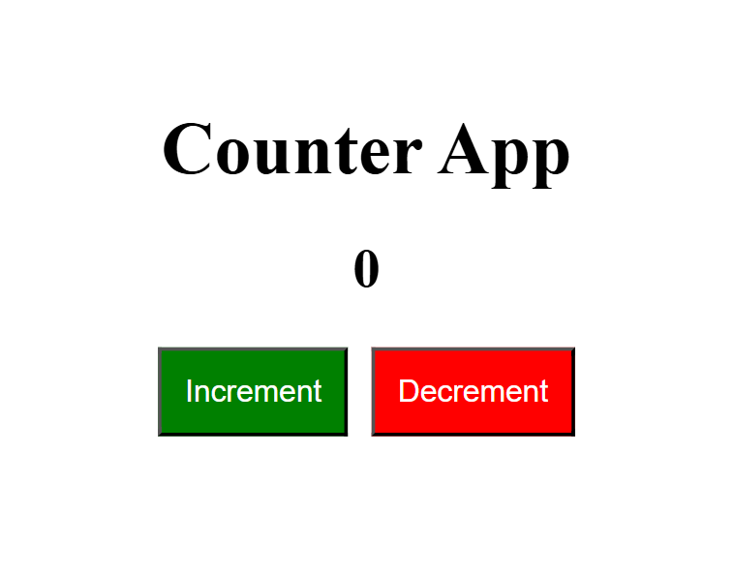

**3] Create Login Lout React program as below**

### Create the Layout Components

#### Navigation Component

importReactfrom'react';

constNavigation= ({ isLoggedIn, handleLogin }) => {

  return (

    <navstyle={{ padding:'10px', backgroundColor:'orange' , width:'200px', height:'50px',}}>

      <h2>Navigation</h2>

      <buttononClick={handleLogin}style={{ padding:'10px', margin:'10px',marginLeft:'150px', markerEnd:'200px' }}>

        {isLoggedIn ?'Logout' :'Login'}

      </button

    </nav>

  );

};

exportdefaultNavigation;

**Public Views Component**

Create a file named PublicViews.js:

importReactfrom'react';

constPublicViews= () => {

  return (

    <div>

      <h2>Public Views</h2>

    </div>

  ); };

exportdefaultPublicViews;

**Private Views Component**

**Create a file named PrivateViews.js:**

importReactfrom'react';

constPrivateViews= () => {

  return (

    <div>

      <h2>Private Views</h2>

    </div>

  );

};

exportdefaultPrivateViews;

**Footer Component**

**Create a file named Footer.js:**

importReactfrom'react';

constFooter= () => {

  return (

    <footerstyle={{ padding:'10px', backgroundColor:'green', marginTop:'20px', width:'200px' }}>

      <p>Footer</p>

    </footer>

  );

};

exportdefaultFooter;

### Create the Main App Component

importReact, { useState } from'react';

importNavigationfrom'./Navigation';

importPublicViewsfrom'./PublicViews';

importPrivateViewsfrom'./PrivateViews';

importFooterfrom'./Footer';

functionApp() {

  const [isLoggedIn, setIsLoggedIn] =useState(false);

  consthandleLogin= () => {

    setIsLoggedIn(!isLoggedIn);

  };

  return (

    <divclassName="App">

      <NavigationisLoggedIn={isLoggedIn}handleLogin={handleLogin}/>

      {isLoggedIn ?<PrivateViews/> : <PublicViews/>}

      <Footer/>

    </div>

  );

}

exportdefaultApp;

